**MODULE 4 ASSESSMENT**

**Name:** Josiah Joed G. Getes

**Course & Year:** BSCS – 1

* Write a C++ procedure to count the number of substrings from a given string

**CODE:**

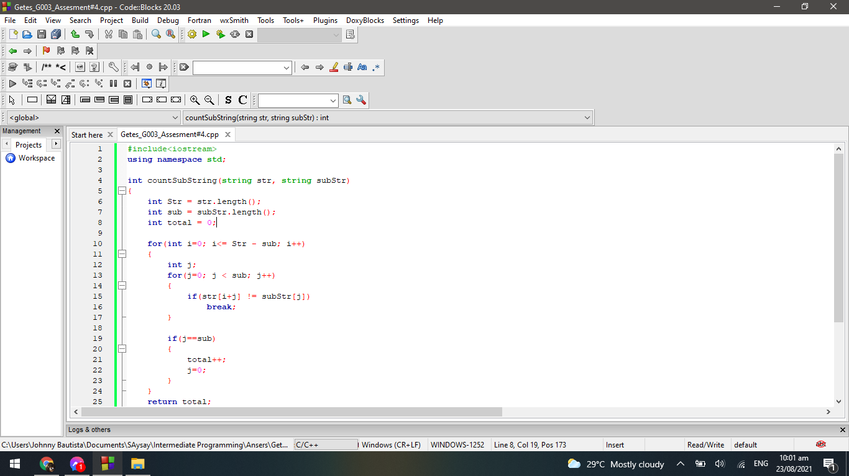**e**

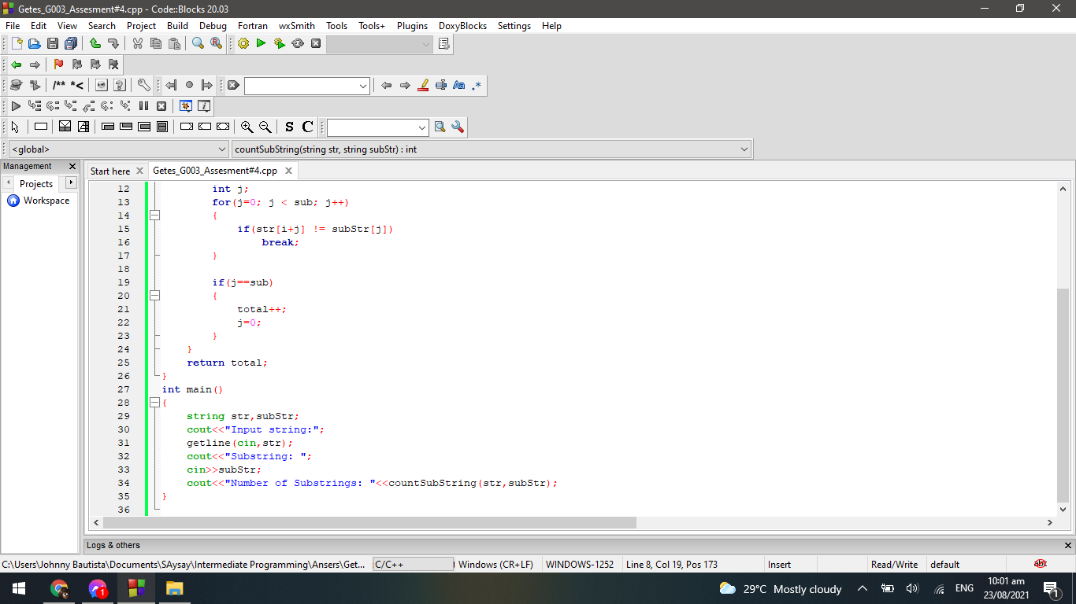

**OUTPUT:**

